**Spike:** 16

**Title:** Collisions

**Author:** Parth Madhani, 101901858

**Goals / deliverables:**

* Code
* A developer familiar with simple box and circle based collision test techniques suitable for use in 2D games and their differences.

**Technologies, Tools, and Resources used:**

* Visual Studio IDE
* Assorted web sources.
  + YouTube
  + Tutorials

**Tasks undertaken:**

* Research SDL2 framework and how to implement collision with it.
* Implement the code.
* Testing code to ensure it all works the same as before.

**What we found out:**

We found out how to use SDL2 to check for collisions.

For rectangle collision :

First we draw rectangles on screen then we set keyboard input for one rectangle so it can move using keys.

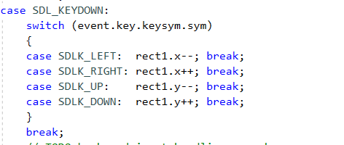

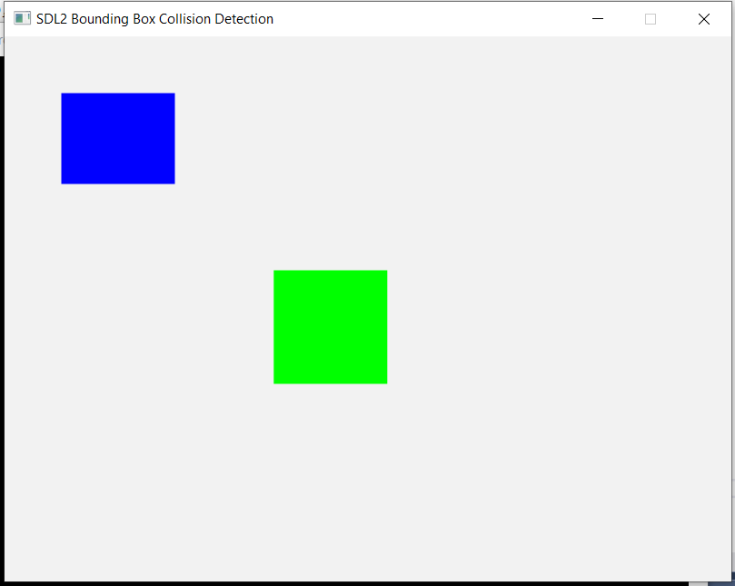

Output with two rectangles drawn.

Then we write code to check for collisions.

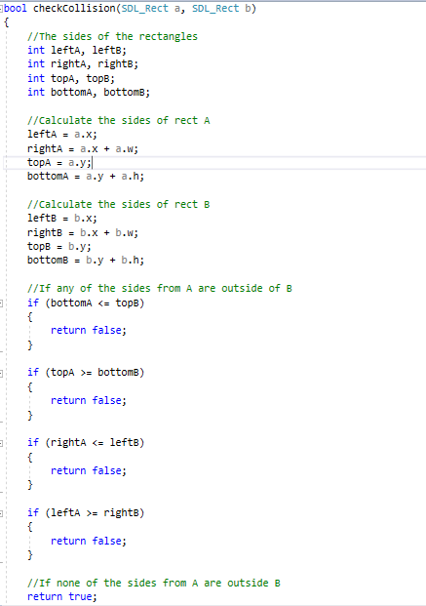

Here it basically checks if any of the sides collides with other rectangle.

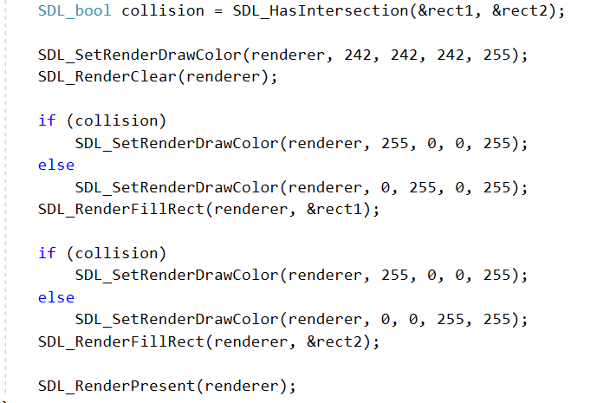

Whenever collision occurs we change color of rectangle to red.

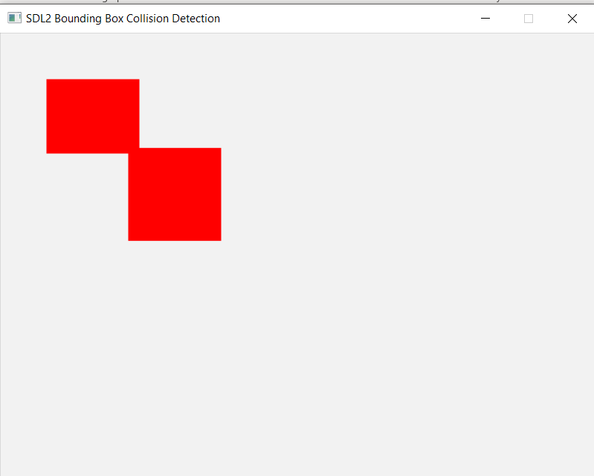

Collision of Rectangles

For Circle :

First we load up two circle images as in SDL2 there is no direct way to draw circle.

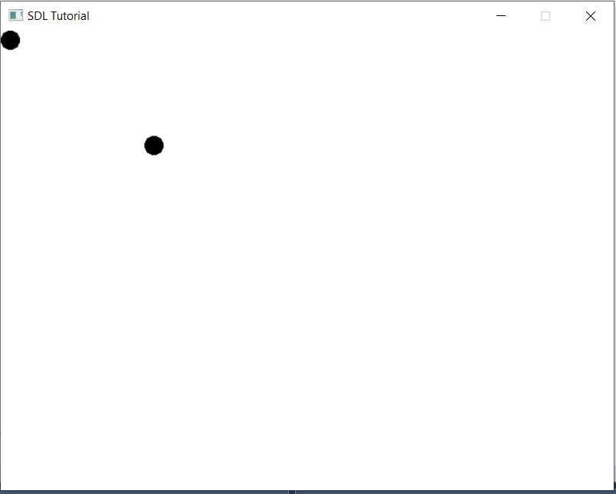

Loading up two circles

Next we check for collision between circles, if collided we change their color to red.

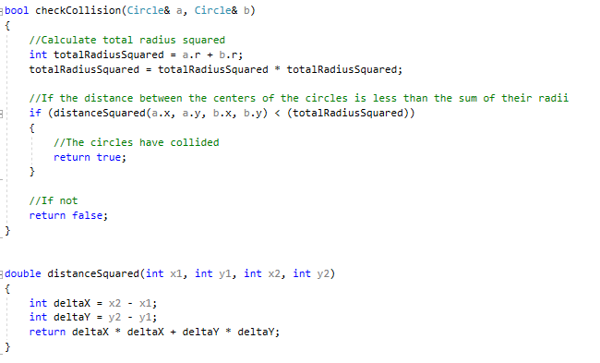

Collision code

Output